To: Oldenburg Town Council
FR: Claire Whalen, OSF, Chair Oldenburg Renewable Energy Commission (OREC)
RE: July, 2019 Report July 1, 2019
OREC members who are working on the town’s greenhouse gas inventory are actively involved in data-gathering for this project. They have completed four online training session learning how to do the data-gathering phase of this study. Currently they have access to the online trainers who are coaching the now 14 city teams in this phase of activity. In mid-July they will input the data into the online software and learn how to analyze and report results.
The Batesville Water and Gas Utility has been most accommodating with sharing the data they have about natural gas use and potable water use for Oldenburg customers. They even printed out a map for us of the town boundaries listing locations of customers living within the town limits to help us select applicable data for town residents only.
Andrea Webster from Indiana University, Bloomington, visited with this inventory team on June 13th to connect with us and answer our questions about data-gathering for the inventory. Denny Moeller stopped by for introductions. A Purdue University student from Batesville, Zach Blomer, heard about the inventory project and asked to assist the team this summer. See photos below taken after the meeting. We will share photos and info on OREC’s page on the town’s website.
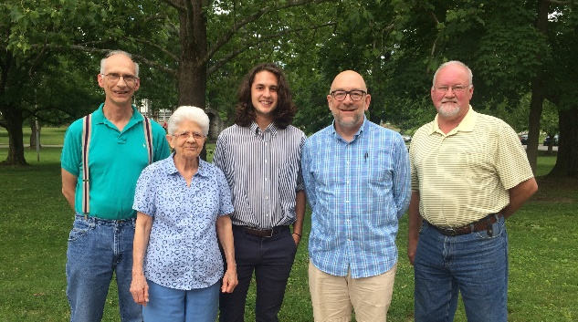
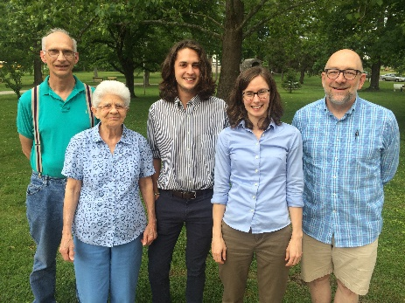
Steve Kristoff, Claire Whalen, OSF, Zach Blomer, Mike Cambron with OTC president, Denny Moeller
Steve Kristoff, Claire Whalen, OSF, Zach Blomer, Andrea Webster (IU staff for ERI), Mike Cambron

OREC members continue to plan for activities and exhibit materials for their booth at Freudenfest in July. We have been able to get support services from several organizations and are listing them as booth sponsors. These include the Sisters of St. Francis, SalesForce Company, Duke Energy and Hoosier Energy with its area REMC’s. These utility companies will be donating LED bulbs for prizes as well as printed materials highlighting energy efficiency actions. We are also including the Oldenburg Town Council as a sponsor since OREC is collaborating with OTC to collect donations for the LED street light upgrade at its festival booth.
Don Lamping created OREC’s page for the town’s website. It is located under the Resources page on that website. OREC’s page is not yet complete, but it has a good beginning. Daryl Werner created a Facebook page for this study group. So between these two communication devices, our study group should have good visibility in Oldenburg and among the town’s visitors. Because OREC’s mission is to provide educational resources for furthering plans and efforts to move towards a more sustainable future using clean energy technologies, these communication avenues are important. That is also the reason for sponsoring a booth at this popular festival that draws not only town residents and nearby neighbors but people from outside our state as well.
Here is a list of the main activities at the OREC booth for Freudenfest this July:
- Hand crank a generator to see how many "watts" you can create
- Calculate your carbon footprint
- View photos/slides of homes with solar systems in our area; talk with some of these folks about the environmental and economic benefits of generating some of their own electricity
- View videos of small German towns that are using 100% renewable energy
- Learn how to be more energy efficient and speak the new “lingo”
- See an actual solar panel in action
- Become a contributor to Oldenburg’s LED street light upgrade and learn how it will save the town money and reduce the town’s carbon footprint
- Win some prizes by visiting the booth

Seven OREC members attended the public presentation of the Oldenburg Comprehensive Plan at Holy Family cafeteria on June 25th before the group’s own meeting that same evening. Claire drafted a suggested response to the wording about OREC’s mission in the Natural Resources chapter of that plan. She hopes to submit it by July 2nd after all the OREC members review it and offer their input. Claire will send you a copy after she sends the suggested word changes to Cory Daly.

The Environmental Resilience webinar for July focused on funding and installing solar systems in Indiana municipalities and gave examples of such installations for the city of South Bend and for Ben Davis High School in Wayne Township outside of Indianapolis. The speakers shared information about funding opportunities and explained how one process worked, namely “guaranteed energy savings control,” or GESC. They shared how communities across the country are working to improve their resilience by deploying solar technology combined with power storage infrastructure. This webinar would be a good resource to view if several businesses or institutions in Oldenburg would show an interest at the same time to explore the use of solar energy to decrease their greenhouse gas emissions. A recording of the webinar is found on the ERI website, https://eri.iu.edu/prepare/resilience-cohort.html.

