To: Oldenburg Town Council
FR: Claire Whalen, OSF, Chair Oldenburg Renewable Energy Commission (OREC)
RE: August, 2019 Report August 1, 2019
July was an especially busy month for OREC members. Action revolved around preparations for the booth activities for Freudenfest weekend and for collecting data for the greenhouse gas emissions inventory.
While the main focus of booth activities was on educational input about conserving energy and choosing sources of renewable energy, we did include the start-up for funding the street light LED upgrade project. We had an attractive booth with free energy efficient materials and free LED light bulbs from the utility sponsors. Equipment demonstration highlighted solar energy—a solar panel powered the fan in the booth—and a hand-crank measured energy output to light a small bulb. However, due to the very hot weather, and the placement of the donation jar at the front of the booth, limited persons visited our booth. OREC members critiqued our efforts at our July 30th meeting and learned from this experience.
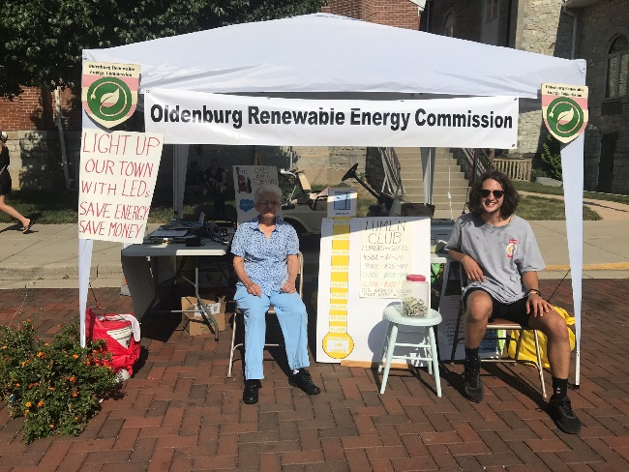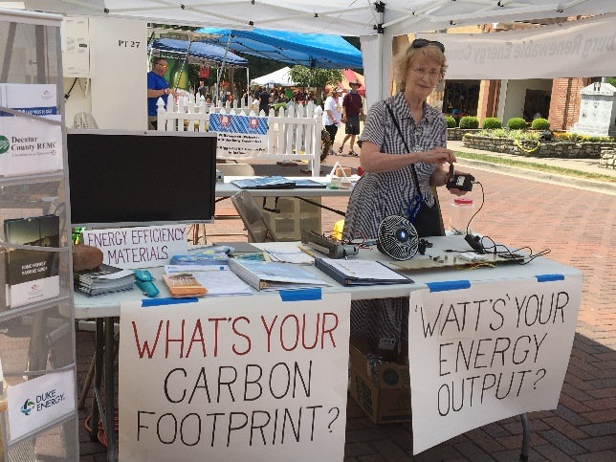
Donations to the street light project amounted to $158.00 from 19 donors including 40% of that amount from OREC members. Besides contributing their planning and executing time, these volunteers also incurred expenses for materials and equipment totaling $483 with a third of that cost for the equipment to operate the hand-crank and the solar panel.
To continue receiving donations for the street light upgrade fund through September, 2019, OREC member, Daryl Werner, created a Go Fund Me Page on OREC’s Facebook page. We encourage you to join that team to invite your friends to make a donation. Visit OREC’s page on the town’s website to see the list of donors for July. New donors will be listed each month. Find the Facebook link on OREC’s webpage. https://www.oldenburgindiana.org/orec
The OREC team handling the greenhouse gas emissions inventory completed the training for this project in late July and is still tracking down data for this inventory. We have yet to obtain data about solid waste pick-up from Caldwell Gravel Services located in Morristown, IN. We will be inputting data we do have to the online Clear Path software of ICLEI on August 5th. Some data on hand is more general than we expected, but we are grateful for those who have supplied such. We will certainly acknowledge in our final report all who have assisted with this project. We expect to have a report to you by your October meeting.

In early July, OREC members did submit suggestions for changes in the town’s comprehensive plan for the Chapter on Natural Resources where the mission of OREC was mentioned. We have not heard from the coordinator if these suggestions have been included in the final draft.
The ERI webinar in July featured the status of electric vehicles and EV charging stations in Indiana. Leah Thill in northern Indiana did a great overview of this emerging technology in the US and in Indiana and highlighted what is happening in her area of the state. Phil Goode with Crawfordsville Electric Light and Power Utility reported on that company’s promotion of electric vehicles and charging stations among its customers. The company is taking the lead with installing the infrastructure to model what the near future would need as well as offering incentives to customers to move in that direction. He gave an overview of the status of EV’s in the Midwest. Both speakers indicated that there would be a big shift to EV’s by 2030 and that businesses and communities will need to have charging infrastructure in place before that time. A recording of the webinar is found on the ERI website, https://eri.iu.edu/prepare/resilience-cohort.html.
I am recommending to our study group that OREC continues to research this technology and prepare a public presentation sometime in 2020 to see how the town of Oldenburg can prepare for the shift from gasoline-fueled internal combustion engines to battery powered electric ones. And as a town that attracts many visitors and tourists, it could be to our advantage to be on the cutting edge of this technology by having charging stations available for such visitors. Maybe the town could request that Duke Energy provide EV incentives and even partner with that utility company to install charging stations. Such action could be a boon to Oldenburg businesses. I am aware of the efforts Decatur County REMC is planning to encourage its members to make EVs their next vehicle purchase.
I have been taking advantage of webinars offered by other groups about renewable energy resources and the need to let elected officials at all levels hear from us ordinary citizens who see the need to revise public policy to favor renewable energy resources in the light of the climate change crisis. One especially on July 30th by Advanced Energy Economy, explained how several state legislatures are moving forward with new laws to promote clean energy and investments in new infrastructure. They even cited Indiana for its recent efforts to keep lobbyists from preventing utility companies to move quickly to diversify their energy portfolios with additional renewable energy sources. To hear this webinar, visit https://info.aee.net/how-these-advanced-energy-bills-became-laws-archive?

